**VEHICLE INSURANCE DATABASE**

Prepared by:

**DBMS(CS310)**

**Group-7:**

Om Morendha(20bcs095) Rishabh Gautam (20bcs112)

Aryan Patel(20bcs097) DharamReddi Chaitanya(20bcs041)

Jaya Prakash(20bcs064) Himanshu Shekhar(20bcs069)

Mohit Saini(20bcs086) Jayant Kumawat (20bcs064)

**Under the Guidance of**

**Dr. Uma Seshadri,**

Professor,

HOD, Department of Computer Science

Indian Institute of Information Technology Dharwad

**Dr. Pramod Yelmewad**

Assistant Professor, Department of Computer Science

Indian Institute of Information Technology Dharwad

**Dr. Supriya Nadiger**

Assistant Professor, Department of Computer Science

****Indian Institute of Information Technology Dharwad

**Acknowledgement**

We would like to sincerely and profusely thank Dr Pramod Yelmewad, for his able guidance and support in completing the Project. We would also like to thank Dr Uma Seshadri for her guidance and giving us the opportunity to take up this project.

- Group-7 students

**AIM:**

This project provides an overall understanding of theoretical and practical concepts of DBMS, this project helpus in learning advanced modelling, normalization, transactional relational database design, SQL and Procedural language and SQL coding. In this project we get an experience to work on ‘MYSQL WORKBENCH’.

**APPROACH:**

After reading the pdf of vehicle insurance company, we tried to understand all the requirements which are needed to create an error free database. We created a conceptual data model to understand the relationship between different entities. We also created an entity relationship diagram (ER-Diagram) and created all the tables and inserted all relevant data to execute all queries.

**MYSQL WORKBENCH CODE :**

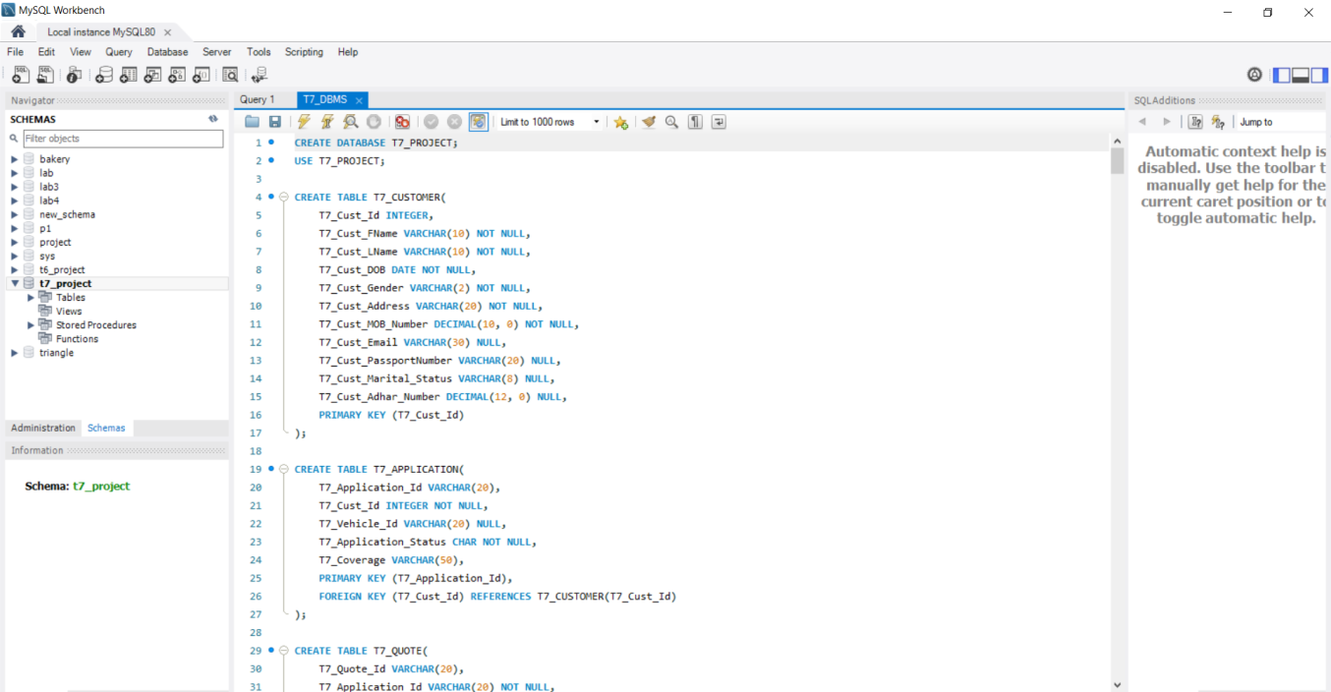

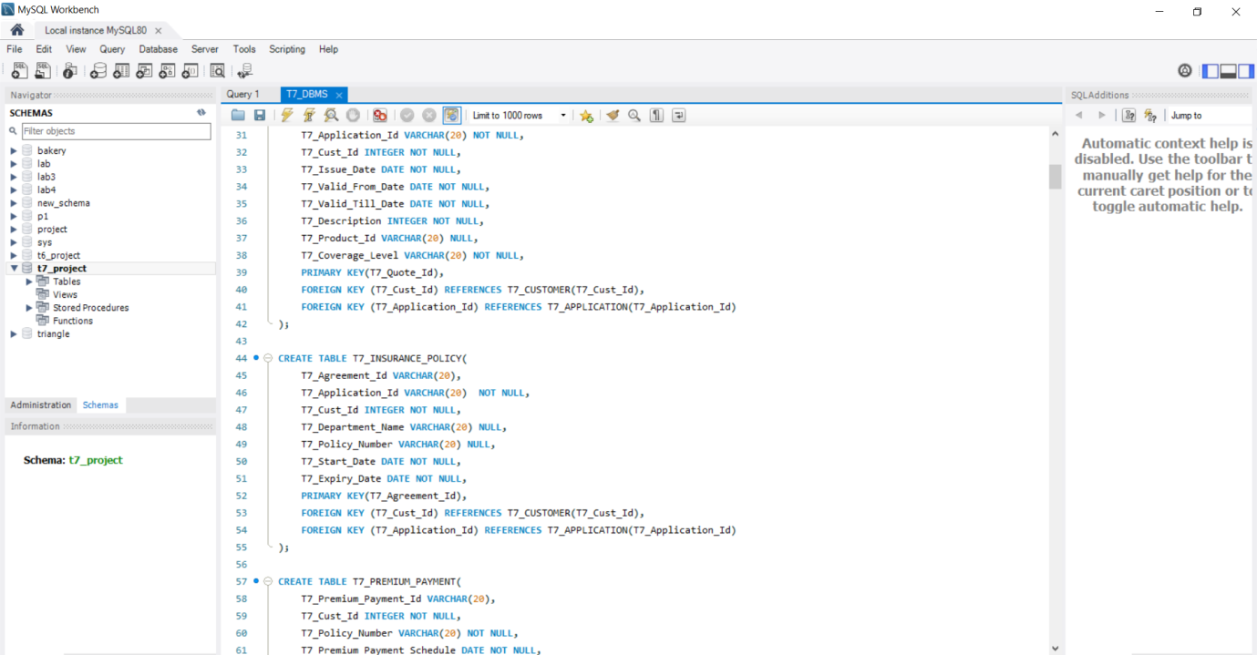

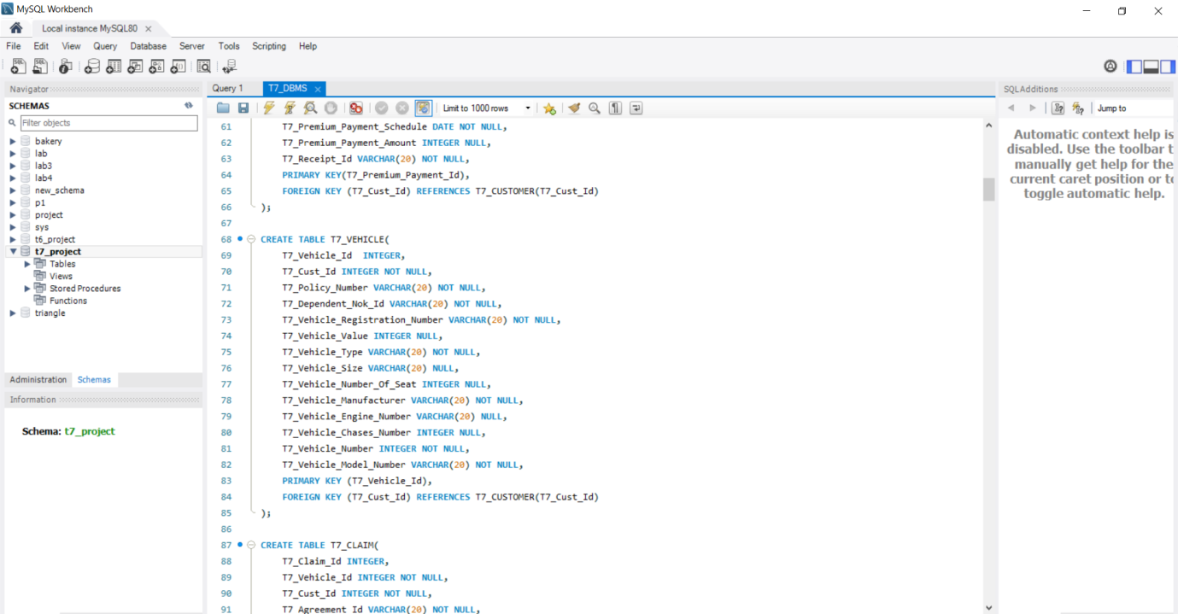

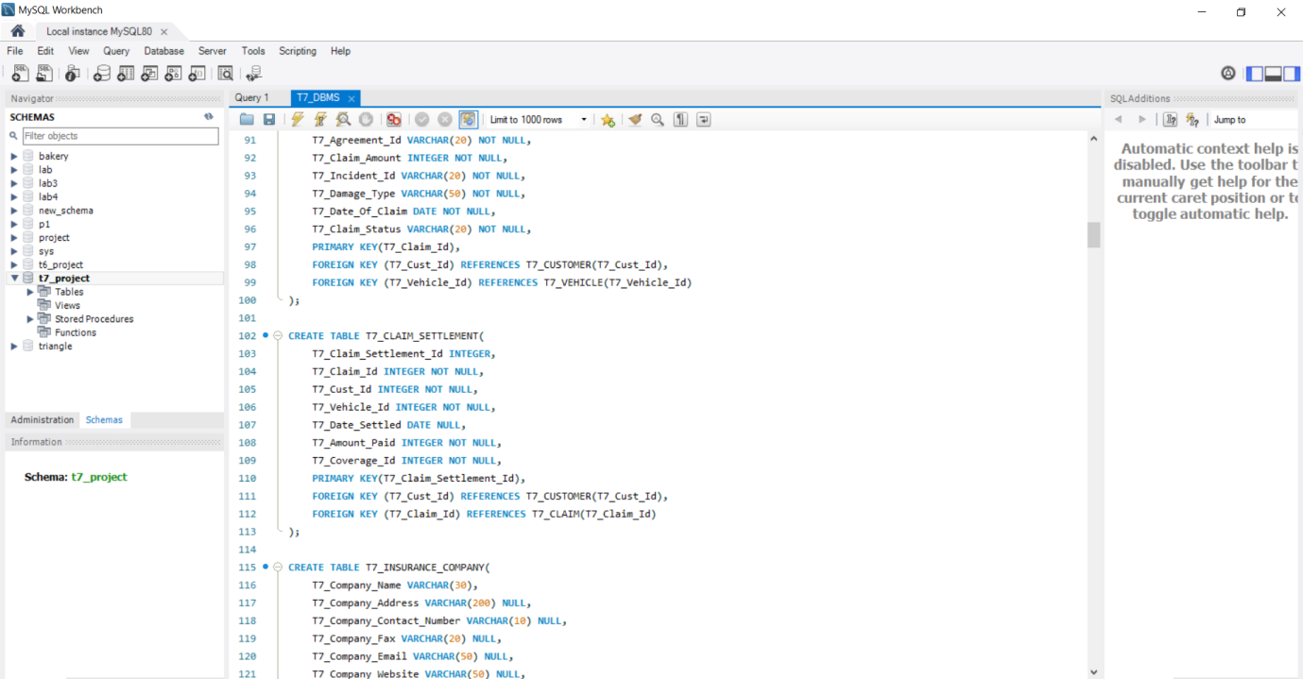

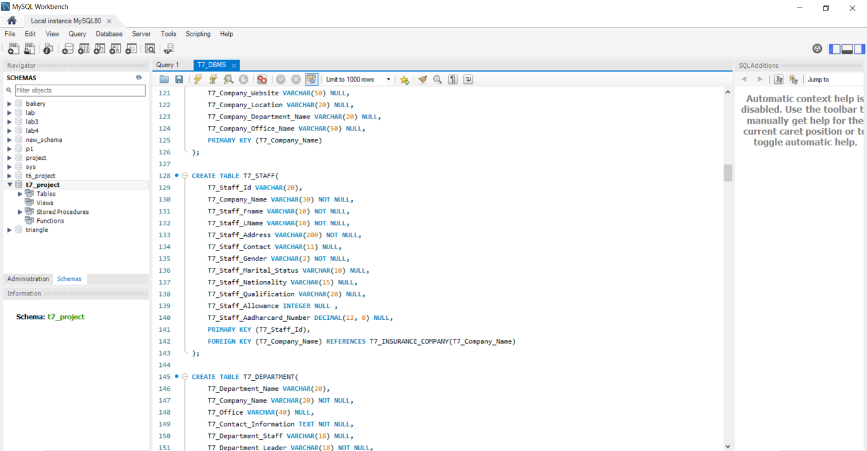

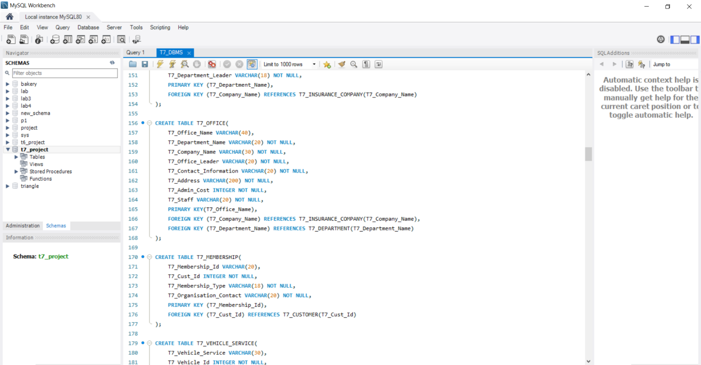

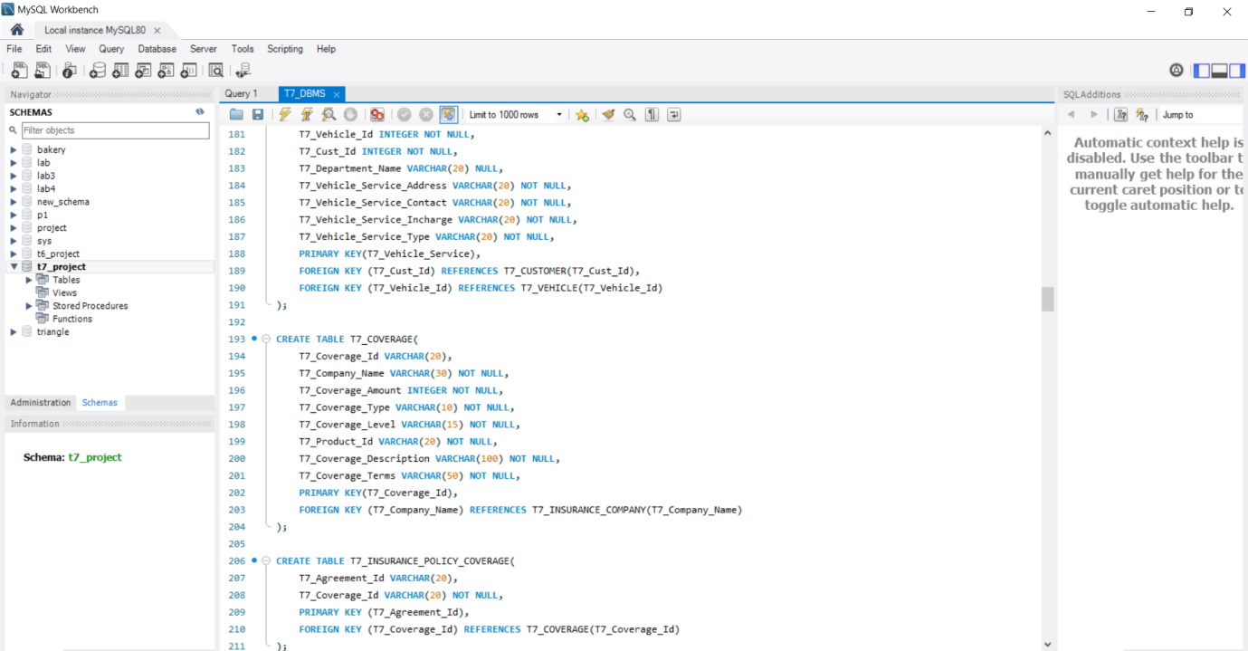

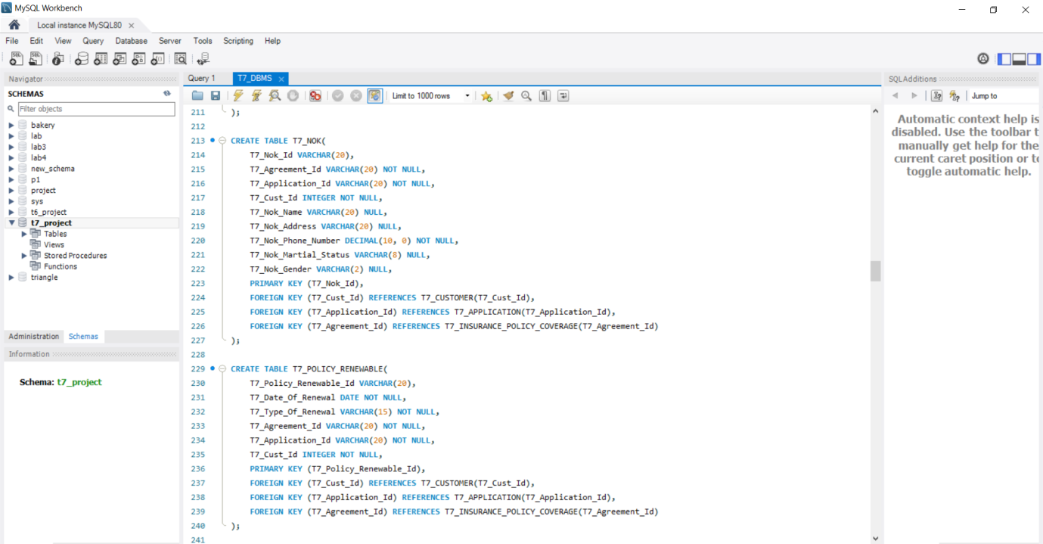

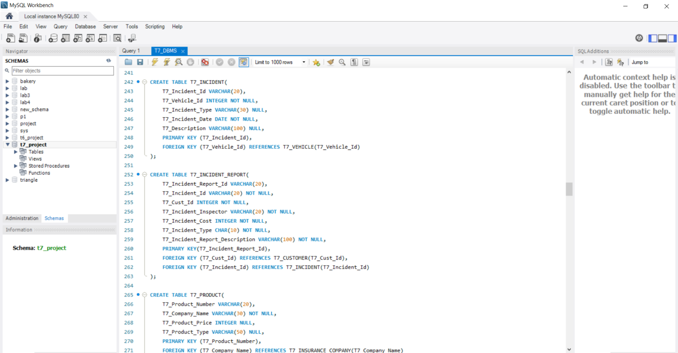

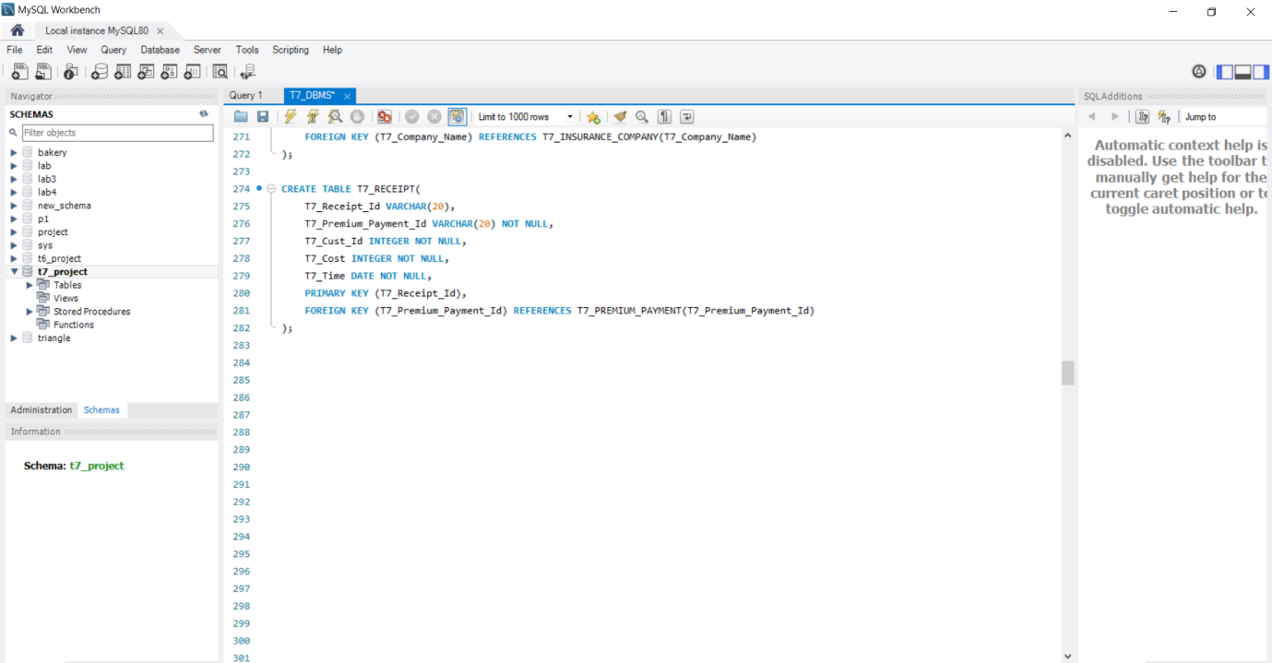

**DATA ENTRY:**

**INSERT INTO T7_CUSTOMER VALUES (100, 'Om', 'Morendha', '2002-05-11', 'M', '102 Modoc Alley', 9099192929, 'om.morendha@gmail.com', 'CXBY2046', 'Single', 728089028912);**

**INSERT INTO T7_CUSTOMER VALUES (180, 'Aryan', 'Patel', '2001-02-17', 'M', '314 Quilly Lane', 7961016050, 'aryan.patel@gmail.com', 'NQCQ3731', 'Married', 364555789632);**

**INSERT INTO T7_CUSTOMER VALUES (260, 'Mohit', 'Saini', '1992-12-06', 'M', '303 Smith Road', 5828466926, 'mohit.saini@gmail.com', 'VIDM8895', 'Single', 603247214690);**

**INSERT INTO T7_CUSTOMER VALUES (340, 'Jayant', 'Kumawat', '1996-01-13', 'M', '145 Ingram Road', 8947847366, 'jayant.kumawat@gmail.com', 'PVEQ8029', 'Married', 227506696956);**

**INSERT INTO T7_CUSTOMER VALUES (420, 'Jaya', 'Prakash', '1989-05-02', 'M', '982 Brannon Street', 2873773753, 'jaya.prakash@gmail.com', 'KOAX1239', 'Single', 509169906227);**

**INSERT INTO T7_CUSTOMER VALUES (500, 'Rishabh', 'Gautam', '1999-08-19', 'M', '263 Pick Street', 4017559124, 'rishabh.gautam@gmail.com', 'OKVW6925', 'Married', 655401850944);**

**INSERT INTO T7_CUSTOMER VALUES (580, 'Himanshu', 'Shekhar', '1984-10-21', 'M', '753 Rogers Street', 7971718823, 'himanshu.shekhar@gmail.com', 'VAJW8832', 'Single', 889290224121);**

**INSERT INTO T7_CUSTOMER VALUES (660, 'Chaitanya', 'Reddy', '1983-05-29', 'M', '112 Monroe Street', 8327182046, 'chaitanya1983@gmail.com', 'AMIE3241', 'Married', 753053145524);**

**INSERT INTO T7_CUSTOMER VALUES (740, 'John', 'Smith', '1995-03-01', 'F', '602 Lighthouse Drive', 2047825582, 'john.smith@gmail.com', 'PCKA2197', 'Single', 631469447322);**

**INSERT INTO T7_CUSTOMER VALUES (820, 'Joan', 'Smith', '1997-02-11', 'F', '701 Spadafore Drive', 4875243506, 'joan.smith@gmail.com', 'CJQM7842', 'Married', 590441142265);**

**INSERT INTO T7_CUSTOMER VALUES (900, 'Pooja', 'Shah', '2000-02-29', 'F', '808 Ethels Lane', 5202069757, 'pooja.shah@gmail.com', 'CPLW2379', 'Married', 143406375182);**

**INSERT INTO T7_CUSTOMER VALUES (980, 'Anushka', 'Patel', '2002-11-14', 'F', '408 Milford Street', 3280963102, 'anushka.patel@gmail.com', 'PUEH7235', 'Single', 175474023282);**

**INSERT INTO T7_CUSTOMER VALUES (1060, 'Priyanka', 'Sharma', '1999-07-25', 'F', '901 Derek Drive', 6749005685, 'priyanka.sharma@gmail.com', 'PXLA7221', 'Married', 761550582014);**

**INSERT INTO T7_CUSTOMER VALUES (1140, 'Neha', 'Chawla', '1998-04-04', 'F', '402 Cantebury Drive', 4883762154, 'neha.chawla@gmail.com', 'LCNW5516', 'Single', 392972069488);**

**INSERT INTO T7_APPLICATION VALUES('A1', 100, 001, 'D', 'High');**

**INSERT INTO T7_APPLICATION VALUES('A2', 100, 002, 'I', 'Medium');**

**INSERT INTO T7_APPLICATION VALUES('A3', 180, 003, 'A', 'High');**

**INSERT INTO T7_APPLICATION VALUES('A4', 340, 004, 'A', 'Low');**

**INSERT INTO T7_APPLICATION VALUES('A5', 420, 005, 'A', 'Medium');**

**INSERT INTO T7_APPLICATION VALUES('A6', 500, 006, 'I', 'High');**

**INSERT INTO T7_APPLICATION VALUES('A7', 660, 007, 'D', 'High');**

**INSERT INTO T7_APPLICATION VALUES('A8', 660, 008, 'A', 'Medium');**

**INSERT INTO T7_APPLICATION VALUES('A9', 660, 009, 'A', 'High');**

**INSERT INTO T7_APPLICATION VALUES('A10', 740, 010, 'A', 'Low');**

**INSERT INTO T7_APPLICATION VALUES('A11', 820, 011, 'I', 'High');**

**INSERT INTO T7_APPLICATION VALUES('A12', 900, 012, 'A', 'Medium');**

**INSERT INTO T7_APPLICATION VALUES('A13', 980, 013, 'A', 'High');**

**INSERT INTO T7_APPLICATION VALUES('A14', 1060, 014, 'D', 'Low');**

**INSERT INTO T7_QUOTE VALUES ('Q1', 'A1', 100, '2020-03-11', '2020-04-11', '2022-04-11', 4463, 'PR1', 'High');**

**INSERT INTO T7_QUOTE VALUES ('Q2', 'A2', 100, '2020-12-17', '2020-12-19', '2021-12-19', 9121, 'PR2', 'Medium');**

**INSERT INTO T7_QUOTE VALUES ('Q3', 'A3', 180, '2019-01-06', '2019-02-06', '2021-02-06', 1498, 'PR3', 'High');**

**INSERT INTO T7_QUOTE VALUES ('Q4', 'A4', 340, '2018-07-13', '2018-09-13', '2020-09-13', 8601, 'PR4', 'Low');**

**INSERT INTO T7_QUOTE VALUES ('Q5', 'A5', 420, '2019-09-02', '2019-09-02', '2022-09-02', 9172, 'PR5', 'Medium');**

**INSERT INTO T7_QUOTE VALUES ('Q6', 'A6', 500, '2019-02-19', '2019-05-19', '2020-05-19', 4321, 'PR6', 'High');**

**INSERT INTO T7_QUOTE VALUES ('Q7', 'A7', 660, '2017-09-21', '2017-09-21', '2021-09-21', 7591, 'PR7', 'High');**

**INSERT INTO T7_QUOTE VALUES ('Q8', 'A8', 660, '2021-05-29', '2021-08-29', '2023-08-29', 2351, 'PR8', 'Medium');**

**INSERT INTO T7_QUOTE VALUES ('Q9', 'A9', 660, '2022-11-01', '2022-11-01', '2023-11-01', 6725, 'PR9', 'High');**

**INSERT INTO T7_QUOTE VALUES ('Q10', 'A10', 740,'2022-01-11', '2022-02-11', '2022-02-11', 9823, 'PR10', 'Low');**

**INSERT INTO T7_QUOTE VALUES ('Q11', 'A11', 820, '2021-12-29', '2021-01-29', '2022-01-29', 1002, 'PR11', 'High');**

**INSERT INTO T7_QUOTE VALUES ('Q12', 'A12', 900, '2020-01-14', '2020-01-14', '2022-01-14', 1200, 'PR12', 'Medium');**

**INSERT INTO T7_QUOTE VALUES ('Q13', 'A13', 980, '2018-02-25', '2018-02-25', '2019-02-25', 4921, 'PR13', 'High');**

**INSERT INTO T7_QUOTE VALUES ('Q14', 'A14', 1060, '2017-03-04', '2017-05-04', '2019-05-04', 6724, 'PR14', 'Low');**

**INSERT INTO T7_INSURANCE_POLICY VALUES ('AG1' , 'A1', 100 , 'BJA_Marketing', 'P1', '2020-04-11', '2022-04-11');**

**INSERT INTO T7_INSURANCE_POLICY VALUES ('AG2' , 'A2', 180 , 'BJA_Accounting', 'P2', '2020-12-19', '2021-12-19');**

**INSERT INTO T7_INSURANCE_POLICY VALUES ('AG3' , 'A3', 180 , 'BJA_Finance', 'P3', '2019-02-06', '2021-02-06');**

**INSERT INTO T7_INSURANCE_POLICY VALUES ('AG4' , 'A4', 340 , 'UNI_Marketing', 'P4', '2018-09-13', '2020-09-13');**

**INSERT INTO T7_INSURANCE_POLICY VALUES ('AG5' , 'A5', 420 , 'UNI_Production', 'P5', '2019-09-02', '2022-09-02');**

**INSERT INTO T7_INSURANCE_POLICY VALUES ('AG6' , 'A6', 500 , 'UNI_Accounting', 'P6', '2019-05-19', '2020-05-19');**

**INSERT INTO T7_INSURANCE_POLICY VALUES ('AG7' , 'A7', 660 , 'UNI_Finance', 'P7', '2017-09-21', '2021-09-21');**

**INSERT INTO T7_INSURANCE_POLICY VALUES ('AG8' , 'A8', 660 , 'HE_Finance', 'P8', '2021-08-29', '2023-08-29');**

**INSERT INTO T7_INSURANCE_POLICY VALUES ('AG9' , 'A9', 660 , 'HE_Accounter', 'P9', '2022-11-01', '2023-11-01');**

**INSERT INTO T7_INSURANCE_POLICY VALUES ('AG10', 'A10', 740, 'HE_Accounting', 'P10', '2022-02-11', '2022-02-11');**

**INSERT INTO T7_INSURANCE_POLICY VALUES ('AG11', 'A11', 820, 'BA_Purchase', 'P11', '2021-01-29', '2022-01-29');**

**INSERT INTO T7_INSURANCE_POLICY VALUES ('AG12', 'A12', 900, 'BA_Purchase', 'P12', '2020-01-14', '2022-01-14');**

**INSERT INTO T7_INSURANCE_POLICY VALUES ('AG13', 'A13', 980, 'BA_Business', 'P13', '2018-02-25', '2019-02-25');**

**INSERT INTO T7_INSURANCE_POLICY VALUES ('AG14', 'A14', 1060, 'BA_Marketing', 'P14', '2017-05-04', '2019-05-04');**

**INSERT INTO T7_PREMIUM_PAYMENT VALUES('P1001', 100, 'P1', '2020-03-11', 7000, 'R001');**

**INSERT INTO T7_PREMIUM_PAYMENT VALUES('P1002', 100, 'P2', '2020-12-19', NULL, 'R002');**

**INSERT INTO T7_PREMIUM_PAYMENT VALUES('P1003', 180, 'P3', '2019-01-08', 8300, 'R003');**

**INSERT INTO T7_PREMIUM_PAYMENT VALUES('P1004', 340, 'P4', '2018-07-13', 8000, 'R004');**

**INSERT INTO T7_PREMIUM_PAYMENT VALUES('P1005', 420, 'P5', '2019-09-05', NULL, 'R005');**

**INSERT INTO T7_PREMIUM_PAYMENT VALUES('P1006', 500, 'P6', '2019-02-21', 7500, 'R006');**

**INSERT INTO T7_PREMIUM_PAYMENT VALUES('P1007', 660, 'P7', '2020-03-11', NULL, 'R007');**

**INSERT INTO T7_PREMIUM_PAYMENT VALUES('P1008', 660, 'P8', '2017-02-21', 7800, 'R008');**

**INSERT INTO T7_PREMIUM_PAYMENT VALUES('P1009', 660, 'P9', '2022-11-01', 9600, 'R009');**

**INSERT INTO T7_PREMIUM_PAYMENT VALUES('P1010', 740, 'P10', '2022-01-16', 8000, 'R0010');**

**INSERT INTO T7_PREMIUM_PAYMENT VALUES('P1011', 820, 'P11', '2021-12-31', NULL, 'R0011');**

**INSERT INTO T7_PREMIUM_PAYMENT VALUES('P1012', 900, 'P12', '2020-01-14', 9600, 'R0012');**

**INSERT INTO T7_PREMIUM_PAYMENT VALUES('P1013', 980, 'P13', '2018-02-25', 7050, 'R0013');**

**INSERT INTO T7_PREMIUM_PAYMENT VALUES('P1014', 1060, 'P14', '2017-03-04', 10000, 'R0014');**

**INSERT INTO T7_VEHICLE VALUES(001, 100, 'P1', 'ND1001', 'VR1001', 1305000, 'Four Wheeler', '15.2msq', 4,'TATA', 51368464641, 7654, 1000, 'Harrier');**

**INSERT INTO T7_VEHICLE VALUES(002, 100, 'P2', 'ND1002', 'VR1002', 605000, 'Four Wheeler', '7.2msq',4, 'TATA', 51648464641, 5454, 2000, 'Nexon');**

**INSERT INTO T7_VEHICLE VALUES(003, 180, 'P3', 'ND1003', 'VR1003', 130000, 'Two Wheeler', '3m', 2,'Bajaj', 514654464641, 7554, 3000, 'Discover');**

**INSERT INTO T7_VEHICLE VALUES(004, 340, 'P4', 'ND1004', 'VR1004', 805000, 'Four Wheeler', '16.2msq', 5, 'Maruti Suzuki', 47168464641, 9554, 4000, 'Baleno');**

**INSERT INTO T7_VEHICLE VALUES(005, 420, 'P5', 'ND1005', 'VR1005', 1005000, 'Four Wheeler', '14.5msq', 5,'Toyota', 74868464641, 8924, 5000, 'Fourtuner');**

**INSERT INTO T7_VEHICLE VALUES(006, 500, 'P6', 'ND1006', 'VR1006', 105000, 'Two Wheeler', '2.2m',2, 'Hero', 68478464641, 9578, 6000, 'Splender PLus');**

**INSERT INTO T7_VEHICLE VALUES(007, 660, 'P7', 'ND1007', 'VR1007', 705000, 'Four Wheeler', '13.7msq',6, 'Maruti Suzuki', 48968464641, 8954, 7000, 'Baleno');**

**INSERT INTO T7_VEHICLE VALUES(008, 660, 'P8', 'ND1008', 'VR1008', 905000, 'Four Wheeler', '12.42msq',4, 'Mahindra', 213646264641, 4862, 8000, 'Scarpio');**

**INSERT INTO T7_VEHICLE VALUES(009, 660, 'P9', 'ND1009', 'VR1009', 130000, 'Two Wheeler', '12.2m',2, 'Honda', 98678464641, 4414, 9000, 'Shine');**

**INSERT INTO T7_VEHICLE VALUES(010, 740, 'P10', 'ND10010', 'VR10010', 505000, 'Four Wheeler', '9.5msq',4, 'Maruti Suzuki', 90918464641, 5871, 10000, 'Alto');**

**INSERT INTO T7_VEHICLE VALUES(011, 820, 'P11', 'ND10011', 'VR10011', 105000, 'Two Wheeler', '3.2m',2, 'Hero', 61348464640, 7014, 11000, 'Splender Pro');**

**INSERT INTO T7_VEHICLE VALUES(012, 900, 'P12', 'ND10012', 'VR10012', 1005000, 'Four Wheeler', '13.2msq', 4,'TATA', 97128464641, 1154, 12000, 'Safari');**

**INSERT INTO T7_VEHICLE VALUES(013, 980, 'P13', 'ND10013', 'VR10013', 905000, 'Four Wheeler', '10.2msq', 4,'Mahindra', 70368464641, 3354, 13000, 'XUV300');**

**INSERT INTO T7_VEHICLE VALUES(014, 1060, 'P14', 'ND10014', 'VR10014', 105000, 'Four Wheeler', '11.2msq', 4,'TATA', 11468464641, 3924, 14000, 'Safari');**

**INSERT INTO T7_CLAIM VALUES(000101, 001, 100, 'AG1', 2500, 'I101', 'HeadLight Damage', '2021-05-05', 'SUCCESS');**

**INSERT INTO T7_CLAIM VALUES(000102, 002, 100, 'AG2', 2500, 'I102', 'Side Mirror Damage', '2020-05-15', 'Pending');**

**INSERT INTO T7_CLAIM VALUES(000103, 003, 180, 'AG3', 1300, 'I103', 'Engine Damage', '2021-04-12', 'SUCCESS');**

**INSERT INTO T7_CLAIM VALUES(000104, 004, 340, 'AG4', 2000, 'I104', 'Front Mirror Damage', '2019-03-19', 'Pending');**

**INSERT INTO T7_CLAIM VALUES(000105, 005, 420, 'AG5', 1000, 'I105', 'Driver Side Window Damage', '2019-11-20', 'SUCCESS');**

**INSERT INTO T7_CLAIM VALUES(000106, 006, 500, 'AG6', 7000, 'I106', 'Bumper Damage', '2020-12-12', 'SUCCESS');**

**INSERT INTO T7_CLAIM VALUES(000107, 007, 660, 'AG7', 10500, 'I107', 'Side Mirror', '2021-02-06', 'Pending');**

**INSERT INTO T7_CLAIM VALUES(000108, 008, 660, 'AG8', 1900, 'I108', 'Gear Box Not Working', '2020-08-13', 'Pending');**

**INSERT INTO T7_CLAIM VALUES(000109, 009, 660, 'AG9', 3500, 'I109', 'HeadLight Damage', '2021-03-31', 'SUCCESS');**

**INSERT INTO T7_CLAIM VALUES(000110, 010, 740, 'AG10', 4500, 'I110', 'Wiser are broken', '2021-08-28', 'SUCCESS');**

**INSERT INTO T7_CLAIM VALUES(000111, 011, 820, 'AG11', 5000, 'I111', 'Car Body Are Burnt Damage', '2021-06-30', 'SUCCESS');**

**INSERT INTO T7_CLAIM VALUES(000112, 012, 900, 'AG12', 5000, 'I112', 'Windshield is Damage', '2021-08-08', 'Pending');**

**INSERT INTO T7_CLAIM VALUES(000113, 013, 980, 'AG13', 10000, 'I113', 'HeadLight Damage', '2021-05-16', 'SUCCESS');**

**INSERT INTO T7_CLAIM VALUES(000114, 014, 1060, 'AG14', 8000, 'I114', 'HeadLight Damage', '2021-11-25', 'SUCCESS');**

**INSERT INTO T7_CLAIM_SETTLEMENT VALUES(200, 000101, 100, 001, '2021-05-12', 2005, 00301);**

**INSERT INTO T7_CLAIM_SETTLEMENT VALUES(201, 000102, 100, 001, NULL, 0, 00302);**

**INSERT INTO T7_CLAIM_SETTLEMENT VALUES(202, 000103, 180, 002, '2021-01-10', 109, 00303);**

**INSERT INTO T7_CLAIM_SETTLEMENT VALUES(203, 000104, 340, 003, NULL, 0, 00303);**

**INSERT INTO T7_CLAIM_SETTLEMENT VALUES(204, 000105, 420, 004, '2021-02-09', 720, 00305);**

**INSERT INTO T7_CLAIM_SETTLEMENT VALUES(205, 000106, 500, 005, '2021-01-01', 5000, 00306);**

**INSERT INTO T7_CLAIM_SETTLEMENT VALUES(206, 000107, 580, 005, '2021-03-20', 10010, 00307);**

**INSERT INTO T7_CLAIM_SETTLEMENT VALUES(207, 000108, 660, 005, NULL, 0, 00308);**

**INSERT INTO T7_CLAIM_SETTLEMENT VALUES(208, 000109, 660, 006, '2021-09-01', 2200, 00309);**

**INSERT INTO T7_CLAIM_SETTLEMENT VALUES(209, 000110, 660, 007, '2021-07-17', 3200, 00310);**

**INSERT INTO T7_CLAIM_SETTLEMENT VALUES(210, 000111, 740, 007, '2021-10-20', 4400, 00311);**

**INSERT INTO T7_CLAIM_SETTLEMENT VALUES(211, 000112, 820, 008, NULL, 0, 00312);**

**INSERT INTO T7_CLAIM_SETTLEMENT VALUES(212, 000113, 900, 009, '2021-06-30', 7800, 00313);**

**INSERT INTO T7_CLAIM_SETTLEMENT VALUES(213, 000114, 980, 009, '2021-08-13', 8000, 00314);**

**INSERT INTO T7_INSURANCE_COMPANY VALUES('Bajaj Allianz', '705 Bengaluru Karnataka', '7895642321', '180045686', 'bajajallianz@gmail.com', 'bajajallianz.com', 'Delhi', 'Finance', 'Bajaj_Allianz_Enclave');**

**INSERT INTO T7_INSURANCE_COMPANY VALUES('United India', '80 Delhi New Delhi', '6201005895', '180054631', 'unitedindia@gmail.com', 'unitedindia.com', 'Mumbai', 'Account', 'United_Building_Indrapuram');**

**INSERT INTO T7_INSURANCE_COMPANY VALUES('IFFCO Tokio', '78 Gandhinagar Gujarat', '6542312354', '18002535', 'iffcotokio@gmail.com', 'iffcoindia.com', 'Gujarat', 'Claim_Department', 'GandhiKunj');**

**INSERT INTO T7_INSURANCE_COMPANY VALUES('National Insurance', '52 Patna Bihar', '8009878526', '12002562', 'nationalinsurance@gmail.com', 'nationalinsurance.com', 'Bihar', 'Finance', 'Company_Office');**

**INSERT INTO T7_INSURANCE_COMPANY VALUES('SBI', '789 Greater Noida Uttar Pradesh', '6201100458', '180085456', 'sbi001@gmail.com', 'sbiindia.com', 'Udaipur', 'Finance', 'Sbi_Enclave');**

**INSERT INTO T7_INSURANCE_COMPANY VALUES('Royal Sundaram', '150 Hubli Karantaka', '8298874205', '18005897', 'royalsundaram123@gmail.com', 'royalsundaram.com', 'Dharwad', 'Claim', 'Royal_Sundram_Building');**

**INSERT INTO T7_INSURANCE_COMPANY VALUES('Future Generali', '500 Ahmedabad Gujarat', '7488388501', '18002567', 'futuregenerali@gmail.com', 'futuregenerali.in', 'Ahmedabad', 'Accounts', 'House_4th_Floor');**

**INSERT INTO T7_INSURANCE_COMPANY VALUES('Shriram', '85 Old Delhi','789456122', '18007892', 'shriram123@gmail.com', 'shriram.in','Delhi', 'Data_Department', 'Shriram_Insurance_Enclave_2nd_Floor');**

**INSERT INTO T7_INSURANCE_COMPANY VALUES('Oriental', '78 Dalal Street Maharasthra', '852741962', '147889125', 'oriental345@yahoo.com', 'orientalinsurance.in', 'Hooghly', 'Claim','Powerhouse_Building');**

**INSERT INTO T7_INSURANCE_COMPANY VALUES('Liberty Motor Insurance', '1256 Shantinagar Madhya Pradesh', '564897225','12549765', 'libertymotor345@gmail.com', 'libertymotor.in', 'Indore', 'Accounts', 'Emperial_Office');**

**INSERT INTO T7_INSURANCE_COMPANY VALUES('Bharti AXA', '456 Dharwad Karantaka', '8794562545', '1548972', 'bhartiaxa@yahoo.com', 'bhartiaxa.com', 'Dharwad', 'Finance', 'Bharti_Office');**

**INSERT INTO T7_INSURANCE_COMPANY VALUES('New India', '487 Ranchi Jharkhand', '6200108978', '180045689', 'newindia154@gmail.com', 'newindia.in', 'Jharkhand', 'Claim', 'Main_Office');**

**INSERT INTO T7_INSURANCE_COMPANY VALUES('Magma HDI', '452 Panji Goa', '7542617892', '158214625', 'magmahdi@gmail.com', 'magmahdi.com', 'Goa', 'Accounts', 'Goan_Office');**

**INSERT INTO T7_INSURANCE_COMPANY VALUES('Chola MS', '456 Tamil Nadu', '6200105848', '180052862', 'cholams@gmail.com', 'cholams.com', 'Tamil_Nadu','Claim_Department', 'Head_Office');**

**INSERT INTO T7_STAFF VALUES('SF001', 'Bajaj allianz', 'Ravi', 'Gupta', '24, 2 Nd Flr, Yamuna Building, Opp Police Station', 9122345768, 'M', 'MARRIED', 'INDIAN', 'BTECH', 2000, 419200203567);**

**INSERT INTO T7_STAFF VALUES('SF002', 'United India', 'Ishaan', 'Sharma', 'Opp Sant Jews, Jarimari Road, Andheri ', 9122345768, 'M', 'UMARRIED', 'INDIAN', 'DIPLOMA', 8000, 110200203567);**

**INSERT INTO T7_STAFF VALUES('SF003', 'Magma HDI', 'Rupesh', 'Agrawal', 'K 3, Shopping Complex Som Vihar Apartment', 9122345768, 'M', 'MARRIED', 'INDIAN', 'BTECH', 9000, 310200205568);**

**INSERT INTO T7_STAFF VALUES('SF004', 'IFFCO Tokio', 'Kaushal', 'Agrawal', '22-7-238/a, Chatta Bazar', 9122345768, 'M', 'UMARRIED', 'INDIAN', 'BTECH', 5500, 220200203567);**

**INSERT INTO T7_STAFF VALUES('SF005', 'National Insurance', 'Nimish', 'Kapoor', ' J-30, White House, Nr Ram Jas Schoolno 2', 9122345768, 'M', 'UMARRIED', 'INDIAN', 'BTECH', 10000,110200273569);**

**INSERT INTO T7_STAFF VALUES('SF006', 'SBI', 'Sarva', 'Mitra', '572/573, Petblr-53, Chickpet', 9122345768, 'M', 'MARRIED', 'INDIAN', 'BSc', 9600, 110200207067);**

**INSERT INTO T7_STAFF VALUES('SF007', 'Royal Sundaram', 'Lokesh', 'Singh', '506, 5th Floor, Faize Quibi, 375 Narshi Natha St',9122345768, 'M', 'MARRIED', 'INDIAN', 'BTECH', 2000,400200203567);**

**INSERT INTO T7_STAFF VALUES('SF008', 'Future Generali', 'Namitha', 'Reddy', '40, Nagdevi Cross Lane, Nagdevi', 9122345768, 'F', 'UMARRIED', 'INDIAN', 'MTECH', 3000, 800200203567);**

**INSERT INTO T7_STAFF VALUES('SF009', 'Shriram', 'Kiran', 'Arya', '127/b, Mittal Towers, Nariman Point', 9122345768, 'F', 'MARRIED', 'INDIAN', 'MTECH', 3900, 111100203567);**

**INSERT INTO T7_STAFF VALUES('SF010', 'Oriental', 'Kareem', 'Khan', ' 75, Ground Kp Main Rd, Yediyou, Jayanagar', 9122345768, 'M', 'MARRIED', 'INDIAN', 'BTECH', 4600, 492000203567);**

**INSERT INTO T7_STAFF VALUES('SF011', 'Liberty Motor Insurance', 'Sheena', 'Malik', ' Z-18, Distric Centre, Transport Authority, Janak Puri', 9122345768, 'F', 'MARRIED', 'INDIAN', 'DIPLOMA', 2800, 556700203567);**

**INSERT INTO T7_STAFF VALUES('SF012', 'Bharti AXA', 'Divyansh', 'Mehta', '78, Site 1 Indl Area, B S Road', 9122345768, 'M', 'UMARRIED', 'INDIAN', 'DIPLOMA', 3700, 882200203567);**

**INSERT INTO T7_STAFF VALUES('SF013', 'New India', 'Aniket', 'Pandey', '77, Elephant Rock Road, Jayanagar', 9122345768, 'M', 'MARRIED', 'INDIAN', 'BTECH', 5000, 110200278007);**

**INSERT INTO T7_DEPARTMENT VALUES('BJA_Marketing', 'Bajaj Allianz', '121/1, Nahar Seth Indl Estate', 'bajaj_all@gmail.com', 'Ravi Gupta', 'Rani Melwani');**

**INSERT INTO T7_DEPARTMENT VALUES('BJA_Accounting', 'Bajaj Allianz', '121/1, Nahar Seth Indl Estate', 'bajaj_all@gmail.com', 'Raju Sharma', 'Sanjay Singh');**

**INSERT INTO T7_DEPARTMENT VALUES('BJA_Finance', 'Bajaj Allianz', '121/1, Nahar Seth Indl Estate', 'bajaj_all@gmail.com', 'Md. Kasim', 'Yuvraj Kuswaha');**

**INSERT INTO T7_DEPARTMENT VALUES('UNI_Marketing', 'United India', 'Parag Indl Estate, Pokhran Road No 1', 'united@uni.ac.in', 'Srinesh Kumar', 'Nirmal Singh');**

**INSERT INTO T7_DEPARTMENT VALUES('UNI_Sales', 'United India', 'Parag Indl Estate, Pokhran Road No 1', 'united@uni.ac.in', 'Ishaan Sharma', 'Siddhant Maurya');**

**INSERT INTO T7_DEPARTMENT VALUES('UNI_Production', 'United India', 'Parag Indl Estate, Pokhran Road No 1', 'united@uni.ac.in', 'Rohit Vargiya', 'Meenakshi Arya');**

**INSERT INTO T7_DEPARTMENT VALUES('UNI_Resource', 'United India', 'Parag Indl Estate, Pokhran Road No 1', 'united@uni.ac.in', 'Karina Sen', 'Vishnu Suraj');**

**INSERT INTO T7_DEPARTMENT VALUES('NI_Marketing', 'National Insurance', '12/13, Tns Lane, Avenue Road', 'national_in@hotmail.com', 'Nimish Kapoor', 'Manisha Verma');**

**INSERT INTO T7_DEPARTMENT VALUES('NI_Sales', 'National Insurance', '12/13, Tns Lane, Avenue Road', 'national_in@hotmail.com', 'Sakal Kumar', 'Richa Singh');**

**INSERT INTO T7_DEPARTMENT VALUES('NI_Accounting', 'National Insurance', '12/13, Tns Lane, Avenue Road', 'national_in@hotmail.com', 'Prem Kumar','Ramesh Vishwakarma');**

**INSERT INTO T7_DEPARTMENT VALUES('BA_Marketing', 'Bharti AXA', '2nd Floor Sambava Chembers, Sir P M Road', 'baxa@gmail.com', 'Divyansh Mehta', 'Arjun Reddy');**

**INSERT INTO T7_DEPARTMENT VALUES('BA_Business', 'Bharti AXA', '2nd Floor Sambava Chembers, Sir P M Road', 'baxa@gmail.com', 'Aakash Shinde', 'Jhon Constantine');**

**INSERT INTO T7_DEPARTMENT VALUES('BA_Purchase', 'Bharti AXA', '2nd Floor Sambava Chembers, Sir P M Road', 'baxa@gmail.com', 'Syeraa Narshima','Prakruti Sharma');**

**INSERT INTO T7_OFFICE VALUES('O1', 'BJA_Marketing', 'Bajaj Allianz', 'Ram', '987654321', 'Bengaluru', 1000, 'Finance');**

**INSERT INTO T7_OFFICE VALUES('O2', 'BJA_Accounting', 'Bajaj Allianz', 'Shubham', '987654322', 'Bharuch', 2000, 'Accounts');**

**INSERT INTO T7_OFFICE VALUES('O3', 'BJA_Finance', 'Bajaj Allianz', 'Lokesh', '987654323', 'Bengaluru', 3000, 'Claim');**

**INSERT INTO T7_OFFICE VALUES('O4', 'UNI_Marketing', 'United India', 'Jhanvi','987654324', 'Patna', 4000, 'Finance');**

**INSERT INTO T7_OFFICE VALUES('O5', 'UNI_Sales', 'United India', 'Tanvi', '987654325', 'Patna', 5000, 'Finance');**

**INSERT INTO T7_OFFICE VALUES('O6', 'UNI_Production', 'United India', 'Siddarth', '987654326', 'Patna', 6000, 'Claim');**

**INSERT INTO T7_OFFICE VALUES('O7', 'UNI_Resource', 'United India', 'Akshat', '987654327', 'Patna', 7000, 'Admin');**

**INSERT INTO T7_OFFICE VALUES('O8', 'NI_Marketing', 'National Insurance', 'Nishant', '987654328', 'Delhi', 8000, 'Admin');**

**INSERT INTO T7_OFFICE VALUES('O9', 'NI_Sales', 'National Insurance', 'Amit', '987654329', 'Delhi', 9000, 'Managment');**

**INSERT INTO T7_OFFICE VALUES('O10', 'NI_Accounting', 'National Insurance', 'Pankaj', '987654310', 'Delhi', 10000, 'Managment');**

**INSERT INTO T7_OFFICE VALUES('O11', 'BA_Marketing', 'Bharti Axa', 'Amar Singh', '987654311', 'Dharwad', 100000, 'Service');**

**INSERT INTO T7_OFFICE VALUES('O12', 'BA_Business', 'Bharti Axa', 'Mamta', '987654222', 'Dharwad', 20000, 'Service');**

**INSERT INTO T7_OFFICE VALUES('O13', 'BA_Purchase', 'Bharti Axa', 'Priti', '987654223', 'Dharwad', 30000, 'Claim');**

**INSERT INTO T7_OFFICE VALUES('O14', 'BA_Business', 'Bharti Axa', 'Shuyam', '987654224', 'Dharwad', 40000, 'Managment');**

**INSERT INTO T7_MEMBERSHIP VALUES('M1001', 100, 'FULL', 'Mumbai');**

**INSERT INTO T7_MEMBERSHIP VALUES('M1002', 180, 'YEARLY', 'Delhi');**

**INSERT INTO T7_MEMBERSHIP VALUES('M1003', 180, 'YEARLY', 'Jaipur');**

**INSERT INTO T7_MEMBERSHIP VALUES('M1004', 340, 'MONTHLY', 'Jodhpur');**

**INSERT INTO T7_MEMBERSHIP VALUES('M1005', 420, 'YEARLY', 'Udaipur');**

**INSERT INTO T7_MEMBERSHIP VALUES('M1006', 500, 'YEARLY', 'Bikaner');**

**INSERT INTO T7_MEMBERSHIP VALUES('M1007', 660, 'YEARLY', 'Jhalore');**

**INSERT INTO T7_MEMBERSHIP VALUES('M1008', 660, 'MONTHLY', 'Jhalawar');**

**INSERT INTO T7_MEMBERSHIP VALUES('M1009', 660, 'YEARLY', 'Pilani');**

**INSERT INTO T7_MEMBERSHIP VALUES('M1010', 740, 'YEARLY', 'Jjn');**

**INSERT INTO T7_MEMBERSHIP VALUES('M1011', 820, 'YEARLY', 'Chirawa');**

**INSERT INTO T7_MEMBERSHIP VALUES('M1012', 900, 'MONTHLY', 'Banglore');**

**INSERT INTO T7_MEMBERSHIP VALUES('M1013', 980, 'MONTHLY', 'Dharwad');**

**INSERT INTO T7_MEMBERSHIP VALUES('M1014', 1060, 'YEARLY', 'Huballi');**

**INSERT INTO T7_VEHICLE_SERVICE VALUES('VS1', 001, 100, 'Air Cleaner', 'Noida', '987654325', 'Rahul', 'MINOR');**

**INSERT INTO T7_VEHICLE_SERVICE VALUES('VS2', 002, 180, 'Transmission', 'Bengaluru', '987654321', 'Shintu', 'MAJOR');**

**INSERT INTO T7_VEHICLE_SERVICE VALUES('VS3', 003, 260, 'Oil Leakage', 'Delhi', '987654322', 'Manish', 'MINOR');**

**INSERT INTO T7_VEHICLE_SERVICE VALUES('VS4', 004, 340, 'Engine', 'Gandhinagar', '987654323', 'Manu', 'MAJOR');**

**INSERT INTO T7_VEHICLE_SERVICE VALUES('VS5',005, 420, 'Body Work', 'Patna', '987654324', 'Banti', 'MAJOR');**

**INSERT INTO T7_VEHICLE_SERVICE VALUES('VS6',006, 500, 'Dent Removal', 'Noida', '987654325', 'Sanjay', 'MINOR');**

**INSERT INTO T7_VEHICLE_SERVICE VALUES('VS7',007, 580, 'Coloring', 'Huballi', '987654326', 'Dinesh', 'MAJOR');**

**INSERT INTO T7_VEHICLE_SERVICE VALUES('VS8',008, 660, 'Air Cleaner', 'Ahemdabad', '987654327', 'Ravindra', 'MINOR');**

**INSERT INTO T7_VEHICLE_SERVICE VALUES('VS9',009, 740, 'Air Cleaner', 'Delhi', '987654328', 'Saurav', 'MINOR');**

**INSERT INTO T7_VEHICLE_SERVICE VALUES('VS10',010, 820, 'Dent', 'Pune', '987654329', 'Ankit', 'MINOR');**

**INSERT INTO T7_VEHICLE_SERVICE VALUES('VS11',011, 900, 'Engine', 'Shantinagar', '987654310', 'Kapil', 'MAJOR');**

**INSERT INTO T7_VEHICLE_SERVICE VALUES('VS12', 012, 980, 'Brake Reparing', 'Dharwad', '987654311', 'Anil', 'MINOR');**

**INSERT INTO T7_VEHICLE_SERVICE VALUES('VS13', 013, 1060, 'Installment', 'Delhi', '987654222', 'Asif', 'MAJOR');**

**INSERT INTO T7_VEHICLE_SERVICE VALUES('VS14', 014, 1140, 'Coloring', 'Panji', '987654223', 'Aslam', 'MAJOR');**

**INSERT INTO T7_COVERAGE VALUES(00301, 'Bajaj Allianz', '2500', 'MAJOR', 'HIGH', 'PD1', '75% Covered by Company', 'ONE YEAR');**

**INSERT INTO T7_COVERAGE VALUES(00302, 'United India', '2400', 'MAJOR', 'HIGH', 'PD2', '60% Covered by Company', 'ONE YEAR');**

**INSERT INTO T7_COVERAGE VALUES(00303, 'IFFCO Tokio', '1500', 'MAJOR', 'HIGH', 'PD3', '33% Covered by Company', 'ONE YEAR');**

**INSERT INTO T7_COVERAGE VALUES(00304, 'National Insurance', '1900', 'MAJOR','HIGH', 'PD4', '59% Covered by Company', 'ONE YEAR');**

**INSERT INTO T7_COVERAGE VALUES(00305, 'SBI', '750', 'MAJOR', 'HIGH', 'PD5', '20% Covered by Company', 'ONE YEAR');**

**INSERT INTO T7_COVERAGE VALUES(00306, 'Royal Sundaram', '6900', 'MAJOR', 'HIGH', 'PD6', '45% Covered by Company', 'ONE YEAR');**

**INSERT INTO T7_COVERAGE VALUES(00307, 'Future Generali', '10500', 'MAJOR', 'HIGH', 'PD7', '50% Covered by Company', 'ONE YEAR');**

**INSERT INTO T7_COVERAGE VALUES(00308, 'Shriram','1800', 'MAJOR', 'HIGH', 'PD8', '80% Covered by Company', 'ONE YEAR');**

**INSERT INTO T7_COVERAGE VALUES(00309, 'Oriental','4100', 'MAJOR', 'HIGH', 'PD9', '49% Covered by Company', 'ONE YEAR');**

**INSERT INTO T7_COVERAGE VALUES(00310, 'Liberty Motor Insurance', '5000', 'MAJOR', 'HIGH', 'PD10', '39% Covered by Company', 'ONE YEAR');**

**INSERT INTO T7_COVERAGE VALUES(00311, 'Bharti AXA', '4500', 'MAJOR', 'HIGH', 'PD11', '35% Covered by Company', 'ONE YEAR');**

**INSERT INTO T7_COVERAGE VALUES(00312, 'Magma HDI', '5000', 'MAJOR', 'HIGH', 'PD12', '90% Covered by Company', 'ONE YEAR');**

**INSERT INTO T7_COVERAGE VALUES(00313, 'Chola MS', '7100', 'MAJOR', 'HIGH', 'PD13', '100% Covered by Company', 'ONE YEAR');**

**INSERT INTO T7_INSURANCE_POLICY_COVERAGE VALUES('AG1', 00301);**

**INSERT INTO T7_INSURANCE_POLICY_COVERAGE VALUES('AG2', 00302);**

**INSERT INTO T7_INSURANCE_POLICY_COVERAGE VALUES('AG3', 00303);**

**INSERT INTO T7_INSURANCE_POLICY_COVERAGE VALUES('AG4', 00304);**

**INSERT INTO T7_INSURANCE_POLICY_COVERAGE VALUES('AG5', 00305);**

**INSERT INTO T7_INSURANCE_POLICY_COVERAGE VALUES('AG6', 00306);**

**INSERT INTO T7_INSURANCE_POLICY_COVERAGE VALUES('AG7', 00307);**

**INSERT INTO T7_INSURANCE_POLICY_COVERAGE VALUES('AG8', 00308);**

**INSERT INTO T7_INSURANCE_POLICY_COVERAGE VALUES('AG9', 00309);**

**INSERT INTO T7_INSURANCE_POLICY_COVERAGE VALUES('AG10', 00310);**

**INSERT INTO T7_INSURANCE_POLICY_COVERAGE VALUES('AG11', 00311);**

**INSERT INTO T7_INSURANCE_POLICY_COVERAGE VALUES('AG12', 00312);**

**INSERT INTO T7_INSURANCE_POLICY_COVERAGE VALUES('AG13', 00313);**

**INSERT INTO T7_NOK VALUES('NK1', 'AG1', 'A1', 100, 'Ajay Morendha', ' 801 Sherpur Patna', 8947847366, 'Single', 'M');**

**INSERT INTO T7_NOK VALUES('NK2', 'AG2', 'A2', 100, 'Pooja Patel', '705 Gandhinagar', 620100456, 'Married', 'F');**

**INSERT INTO T7_NOK VALUES('NK3', 'AG3', 'A3', 180, 'Sharadha Saini', '905 Jaipur', 829652525, 'Married', 'F');**

**INSERT INTO T7_NOK VALUES('NK4', 'AG4', 'A4', 340, 'Neha Kumawat', '456 Bhopal', 987456221, 'Single', 'F');**

**INSERT INTO T7_NOK VALUES('NK5', 'AG5', 'A5', 420, 'Veeru Prakash', '705 Gandhinagar', 620100456, 'Married', 'M');**

**INSERT INTO T7_NOK VALUES('NK6', 'AG6', 'A6', 500, 'Nitin Gautam', '305 Moradabad', 983100456, 'Single', 'M');**

**INSERT INTO T7_NOK VALUES('NK7', 'AG7', 'A7', 660, 'Shakshi Shekhar', '402 Rampur', 508900456, 'Married', 'F');**

**INSERT INTO T7_NOK VALUES('NK8', 'AG8', 'A8', 660, 'Rohan Reddy', '567 Amroha', 850370456, 'Single', 'M');**

**INSERT INTO T7_NOK VALUES('NK9', 'AG9', 'A9', 660, 'Rohan Smith', '409 Aligarh', 942016576, 'Single', 'M');**

**INSERT INTO T7_NOK VALUES('NK10', 'AG10', 'A10', 740, 'Riya Shah', '209 Delhi', 620100908, 'Single', 'F');**

**INSERT INTO T7_NOK VALUES('NK11', 'AG11', 'A11', 820, 'Diksha Patel', '101 Kashipur', 920100456, 'Single', 'F');**

**INSERT INTO T7_NOK VALUES('NK12', 'AG12', 'A12', 900, 'Anushka Sharma', '305 Haldwani', 888100456, 'Single', 'F');**

**INSERT INTO T7_NOK VALUES('NK13', 'AG13', 'A13', 980, 'Aryan Patel', '499 Lucknow', 777700456, 'Married', 'M');**

**INSERT INTO T7_POLICY_RENEWABLE VALUES('PR1001','2022-04-11','First party','AG1','A1',100);**

**INSERT INTO T7_POLICY_RENEWABLE VALUES('PR1002','2021-12-19','Third party','AG2','A2',180);**

**INSERT INTO T7_POLICY_RENEWABLE VALUES('PR1003','2021-02-06','Second party','AG3','A3',260);**

**INSERT INTO T7_POLICY_RENEWABLE VALUES('PR1004','2020-09-13','Third party','AG4','A4',340);**

**INSERT INTO T7_POLICY_RENEWABLE VALUES('PR1005','2022-09-02','First party','AG5','A5',420);**

**INSERT INTO T7_POLICY_RENEWABLE VALUES('PR1006','2020-05-19','Second party','AG6','A6',500);**

**INSERT INTO T7_POLICY_RENEWABLE VALUES('PR1007','2021-09-21','Third party','AG7','A7',580);**

**INSERT INTO T7_POLICY_RENEWABLE VALUES('PR1008','2023-08-29','First party','AG8','A8',660);**

**INSERT INTO T7_POLICY_RENEWABLE VALUES('PR1009','2023-11-01','Second party','AG9','A9',740);**

**INSERT INTO T7_POLICY_RENEWABLE VALUES('PR1010','2022-02-11','Third party','AG10','A10',820);**

**INSERT INTO T7_POLICY_RENEWABLE VALUES('PR1011','2022-01-29','Second party','AG11','A11',900);**

**INSERT INTO T7_POLICY_RENEWABLE VALUES('PR1012','2022-01-14','First party','AG12','A12',980);**

**INSERT INTO T7_POLICY_RENEWABLE VALUES('PR1013','2019-02-25','Second party','AG13','A13',1060);**

**INSERT INTO T7_INCIDENT VALUES('I101',001 ,'Accident', '2021-05-01', 'BODY DAMAGE');**

**INSERT INTO T7_INCIDENT VALUES('I102',002 ,'Loss', '2020-05-05', 'ENGINE FREEZE');**

**INSERT INTO T7_INCIDENT VALUES('I103', 003 ,'Accident', '2021-04-05', 'HEADLIGHT DAMAGE');**

**INSERT INTO T7_INCIDENT VALUES('I104',004 , 'Loss', '2019-03-12', 'DENT');**

**INSERT INTO T7_INCIDENT VALUES('I105',005 , 'Theft', '2019-11-12', 'BRAKE PIPELINE FAILED');**

**INSERT INTO T7_INCIDENT VALUES('I106',006 , 'Accident', '2020-12-04', 'FRONT PART FULLY DAMAGE');**

**INSERT INTO T7_INCIDENT VALUES('I107', 007 ,'Fire', '2021-02-01', 'SIDE MIRROR DAMAGE');**

**INSERT INTO T7_INCIDENT VALUES('I108', 008 ,'Accident', '2020-08-02', 'ENGINE DAMAGE');**

**INSERT INTO T7_INCIDENT VALUES('I109', 009 ,'Accident', '2022-01-12', 'DENT');**

**INSERT INTO T7_INCIDENT VALUES('I110', 010 ,'Loss', '2021-03-25', 'NEW TYRES');**

**INSERT INTO T7_INCIDENT VALUES('I111', 011 ,'Loss', '2021-08-20', 'HEADLIGHT DAMAGE');**

**INSERT INTO T7_INCIDENT VALUES('I112', 012 ,'Fire', '2021-06-20', 'DENT');**

**INSERT INTO T7_INCIDENT VALUES('I113', 013 ,'Accident', '2021-08-04', 'ENGINE WORK');**

**INSERT INTO T7_INCIDENT VALUES('I114', 014 ,'Theft', '2021-05-08', 'FULL BODY CHANGE');**

**INSERT INTO T7_INCIDENT_REPORT VALUES('IR101', 'I101', 100, 'Ram', '10000', 'accident', 'Full Body Damage');**

**INSERT INTO T7_INCIDENT_REPORT VALUES('IR102', 'I102', 180, 'Vivek', '15000', 'Loss', 'Front Part Fully Damage');**

**INSERT INTO T7_INCIDENT_REPORT VALUES('IR103', 'I103', 180, 'Vinit', '1000', 'accident', 'Dent');**

**INSERT INTO T7_INCIDENT_REPORT VALUES('IR104', 'I104', 340, 'Vicky', '2000', 'Loss', 'Headlight Damage');**

**INSERT INTO T7_INCIDENT_REPORT VALUES('IR105', 'I105', 420, 'Aman', '30000', 'Theft','Engine Work Fail');**

**INSERT INTO T7_INCIDENT_REPORT VALUES('IR106', 'I106', 500, 'Vipul', '10000', 'accident', 'Engine Freeze');**

**INSERT INTO T7_INCIDENT_REPORT VALUES('IR107', 'I107', 660, 'Rohit', '1100', 'Fire', 'Tyres Burst');**

**INSERT INTO T7_INCIDENT_REPORT VALUES('IR108', 'I108', 660, 'Kesav', '10000', 'accident', 'Front Part Fully Damage');**

**INSERT INTO T7_INCIDENT_REPORT VALUES('IR109', 'I109', 660, 'Daksh', '550', 'accident', 'Tyres Burst');**

**INSERT INTO T7_INCIDENT_REPORT VALUES('IR110', 'I110', 740, 'Mohit', '1110', 'Loss', 'Dent');**

**INSERT INTO T7_INCIDENT_REPORT VALUES('IR111', 'I111', 820, 'Ashish', '1210', 'Loss', 'Fuel Pipe Burst');**

**INSERT INTO T7_INCIDENT_REPORT VALUES('IR112', 'I112', 900, 'Ravi', '1300', 'Fire', 'Headlight Demage');**

**INSERT INTO T7_INCIDENT_REPORT VALUES('IR113', 'I113', 980, 'Sachin', '12000', 'accident', 'Entire Backend Part Damage');**

**INSERT INTO T7_INCIDENT_REPORT VALUES('IR114', 'I114', 1060, 'Rahul', '13000', 'Theft', 'Engine Work Fail');**

**INSERT INTO T7_PRODUCT VALUES('PD1', 'Bajaj Allianz', 10000, 'Bajaj Allianz Car Economical Insurance');**

**INSERT INTO T7_PRODUCT VALUES('PD2', 'Bajaj Allianz', 11000, 'Bajaj Allianz Car Insurance');**

**INSERT INTO T7_PRODUCT VALUES('PD3', 'Bajaj Allianz', 13000, 'Bajaj Allianz Car Premium Insurance');**

**INSERT INTO T7_PRODUCT VALUES('PD4', 'Bajaj Allianz', 14050, 'Bajaj Allianz Car Super Premium Insurance');**

**INSERT INTO T7_PRODUCT VALUES('PD5', 'Bajaj Allianz', 17000, 'Bajaj Allianz Car Super Premium+ Insurance');**

**INSERT INTO T7_PRODUCT VALUES('PD6', 'United India', 12000, 'United India Car Insurance');**

**INSERT INTO T7_PRODUCT VALUES('PD7', 'United India', 15000, 'United India Car Premium Insurance');**

**INSERT INTO T7_PRODUCT VALUES('PD8', 'National Insurance', 11500, 'National Insurance Insurance');**

**INSERT INTO T7_PRODUCT VALUES('PD9', 'National Insurance', 16000, 'National Insurance Premium Insurance');**

**INSERT INTO T7_PRODUCT VALUES('PD10', 'National Insurance', 19000, 'National Insurance Premium+ Insurance');**

**INSERT INTO T7_PRODUCT VALUES('PD11', 'Bharti AXA', 9500, 'Bharti AXA Car Economical Insurance');**

**INSERT INTO T7_PRODUCT VALUES('PD12', 'Bharti AXA', 12000, 'Bharti AXA Car Insurance');**

**INSERT INTO T7_PRODUCT VALUES('PD13', 'Bharti AXA', 15000, 'Bharti AXA Car Premium Insurance');**

**INSERT INTO T7_PRODUCT VALUES('PD14', 'Bharti AXA', 19400, 'Bharti AXA Car Premium+ Insurance');**

**INSERT INTO T7_RECEIPT VALUES('R001', 'P1001', 100, 7560, '2020-03-11');**

**INSERT INTO T7_RECEIPT VALUES('R002', 'P1002', 100, 8208, '2020-12-19');**

**INSERT INTO T7_RECEIPT VALUES('R003', 'P1003', 180, 8964, '2019-01-08');**

**INSERT INTO T7_RECEIPT VALUES('R004', 'P1004', 340, 8640, '2018-07-13');**

**INSERT INTO T7_RECEIPT VALUES('R005', 'P1005', 420, 9720, '2019-09-05');**

**INSERT INTO T7_RECEIPT VALUES('R006', 'P1006', 500, 8100, '2019-02-21');**

**INSERT INTO T7_RECEIPT VALUES('R007', 'P1007', 660, 6480, '2020-03-11');**

**INSERT INTO T7_RECEIPT VALUES('R008', 'P1008', 660, 8424, '2017-02-21');**

**INSERT INTO T7_RECEIPT VALUES('R009', 'P1009', 660, 10368, '2022-11-01');**

**INSERT INTO T7_RECEIPT VALUES('R0010', 'P1010', 740, 8640, '2022-01-16');**

**INSERT INTO T7_RECEIPT VALUES('R0011', 'P1011', 820, 8964, '2021-12-31');**

**INSERT INTO T7_RECEIPT VALUES('R0012', 'P1012', 900, 10368, '2020-01-14');**

**INSERT INTO T7_RECEIPT VALUES('R0013', 'P1013', 980, 7614, '2018-02-25');**

**INSERT INTO T7_RECEIPT VALUES('R0014', 'P1014', 1060, 10800, '2017-03-04');**

**TIMELINE:**

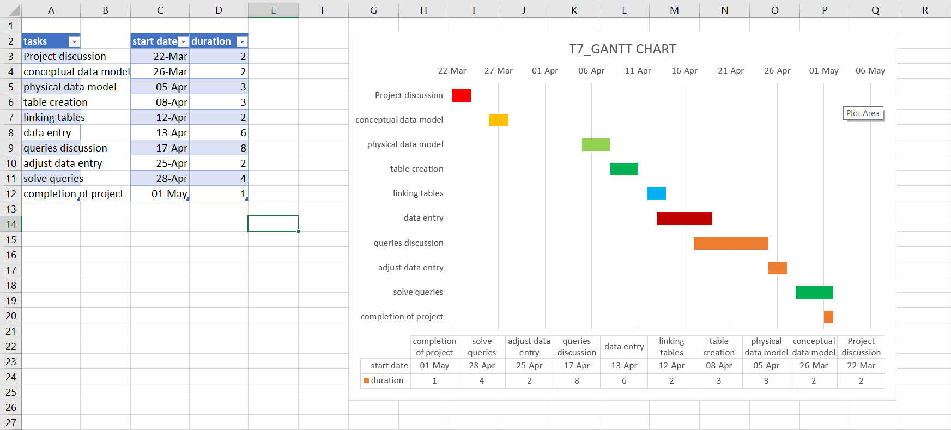

**CONCEPTUAL DATA MODEL:**

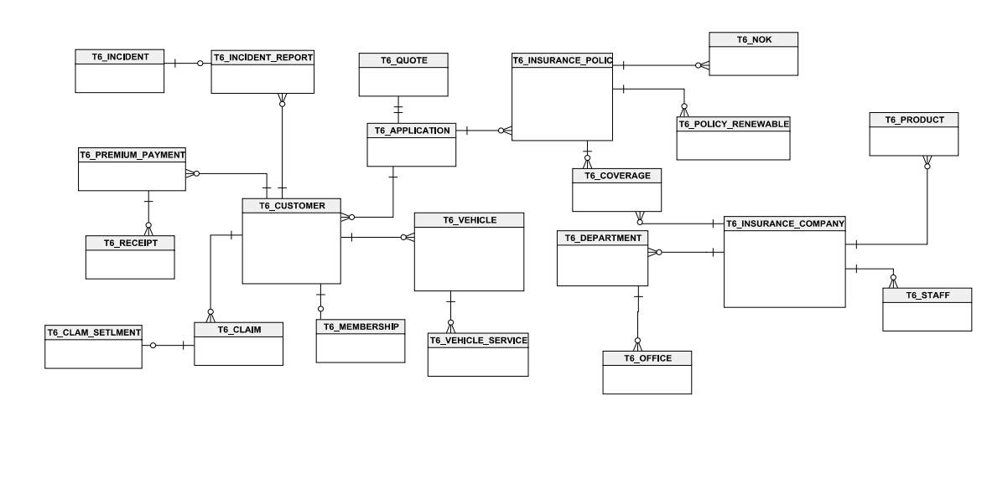

**E-R DIAGRAM:**

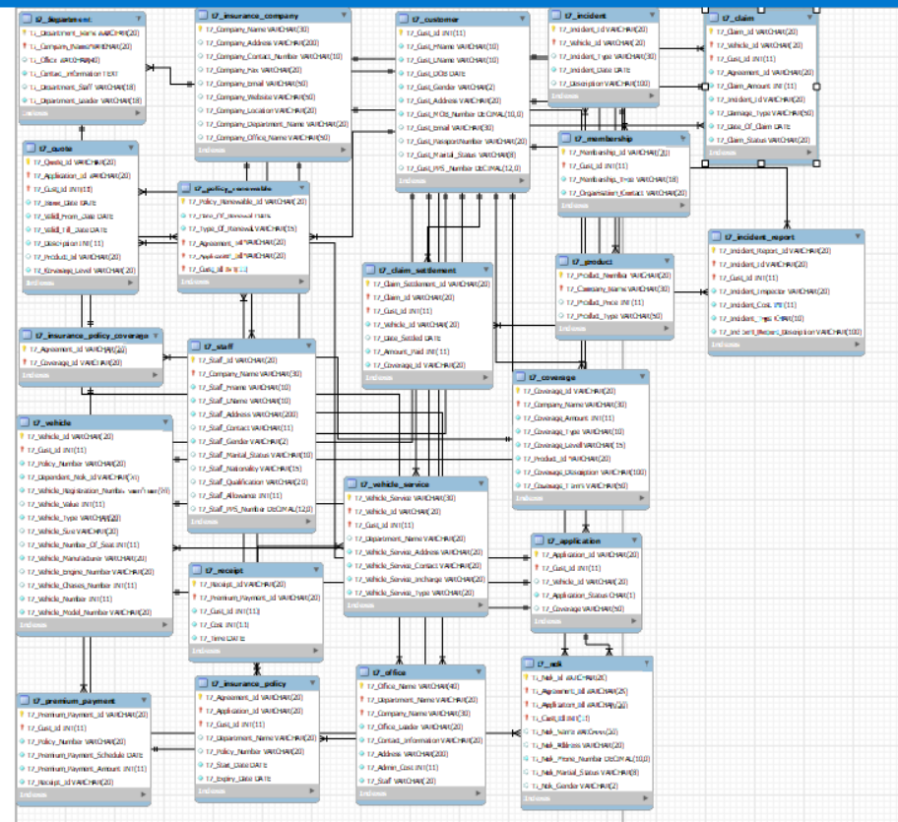

**QUERIES:**

1. Retrieve Customer and Vehicle details who has been involved in an incident and claim status is pending – Customer, vehicle, claim status, incident.

SELECT C.* , V.* FROM T7_CUSTOMER C

INNER JOIN T7_CLAIM CL

ON C.T7_Cust_Id = CL.T7_Cust_Id

INNER JOIN T7_VEHICLE V

ON CL.T7_VEHICLE_Id = V.T7_VEHICLE_Id

INNER JOIN T7_INCIDENT I

ON I.T7_VEHICLE_Id = V.T7_VEHICLE_Id

WHERE CL.T7_Claim_Status = 'Pending';

**OUTPUT:**

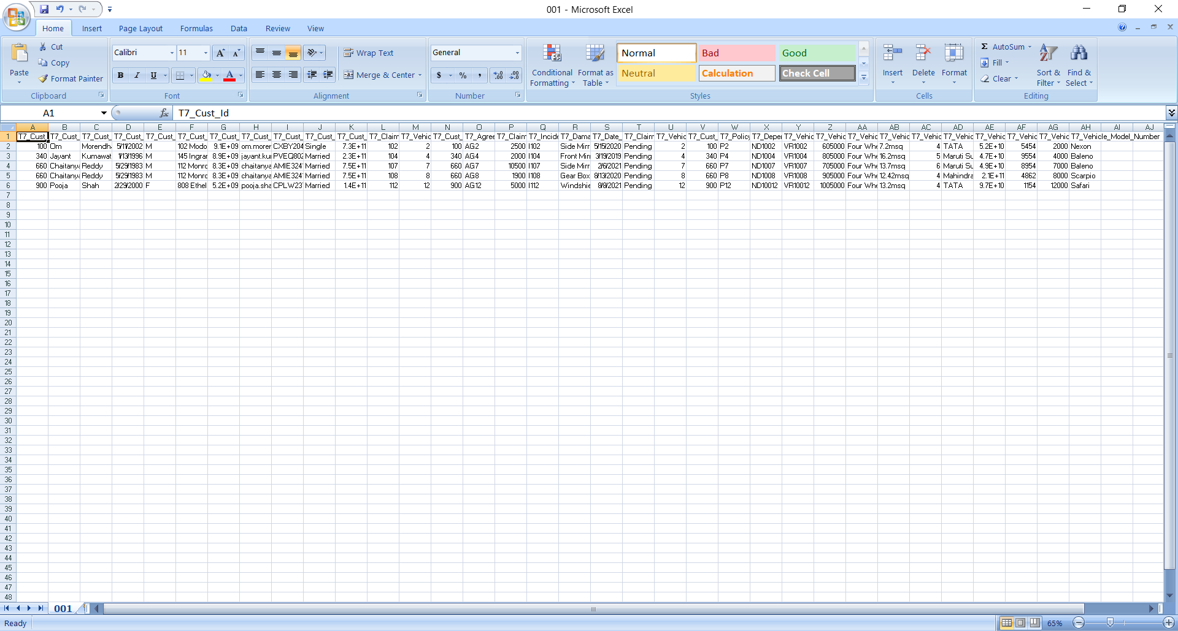

1. Retrieve customer details who has premium payment amount greater than the sum of all the Customer Ids in the database – premium payment, customer

SELECT C.*, P.T7_Premium_Payment_Amount FROM T7_CUSTOMER C

INNER JOIN T7_PREMIUM_PAYMENT P

ON C.T7_Cust_Id = P.T7_Cust_Id

HAVING P.T7_Premium_Payment_Amount > (SELECT SUM(C.T7_Cust_Id) FROM T7_CUSTOMER C);

**OUTPUT:**

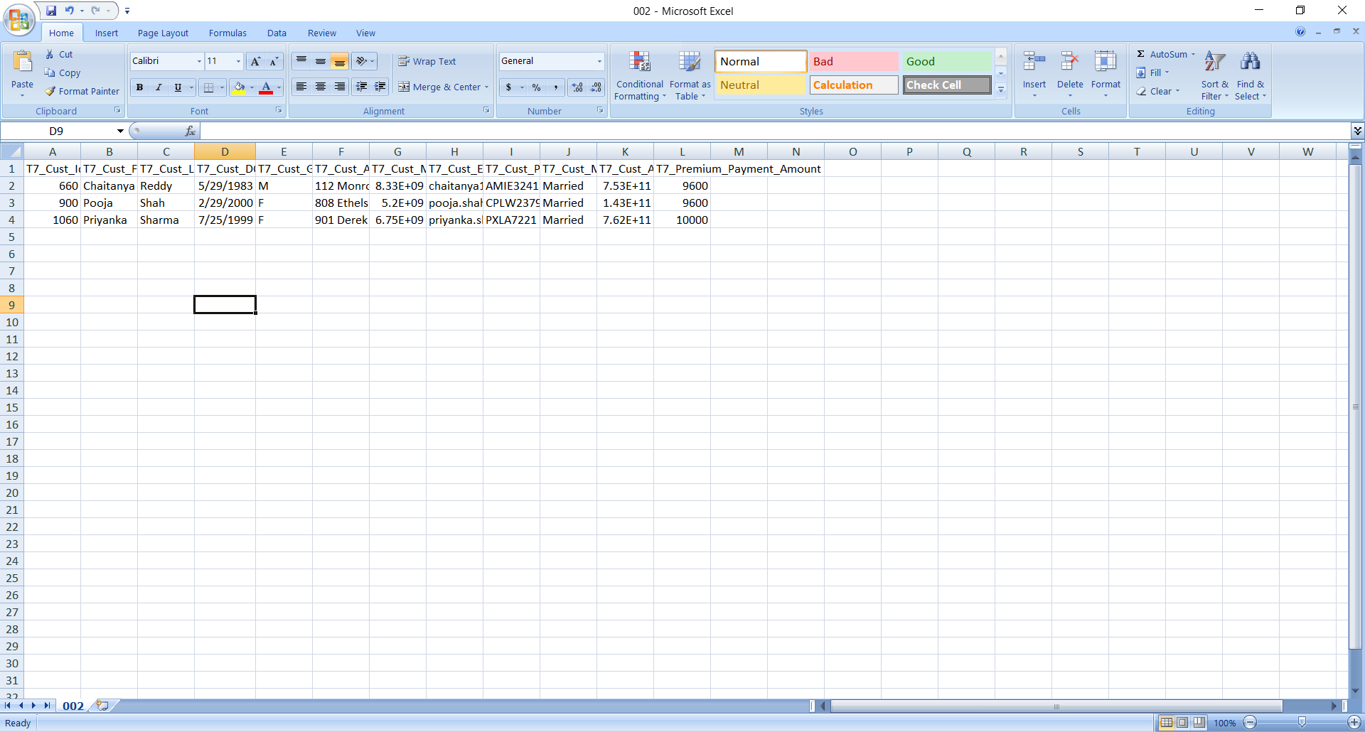

1. Retrieve Company details whose number of products is greater than departments, where the departments are located in more than one location—company, product, departments, office

SELECT * FROM T7_INSURANCE_COMPANY

WHERE T7_Company_Name IN

(SELECT T1.T7_Company_Name

FROM (SELECT T7_Company_Name, COUNT(T7_Company_Name) AS C1 FROM T7_PRODUCT GROUP BY T7_Company_Name) AS T1

INNER JOIN

(SELECT T7_Company_Name, COUNT(T7_Company_Name) AS C2 FROM T7_DEPARTMENT GROUP BY T7_Company_Name) AS T2

ON T1.T7_Company_Name = T2.T7_Company_Name

WHERE T1.C1 > T2.C2)

AND

T7_Company_Name IN

(SELECT T7_Company_Name FROM T7_OFFICE GROUP BY T7_Company_Name HAVING GROUP_CONCAT(DISTINCT T7_Address) LIKE '%,%');

**OUTPUT:**

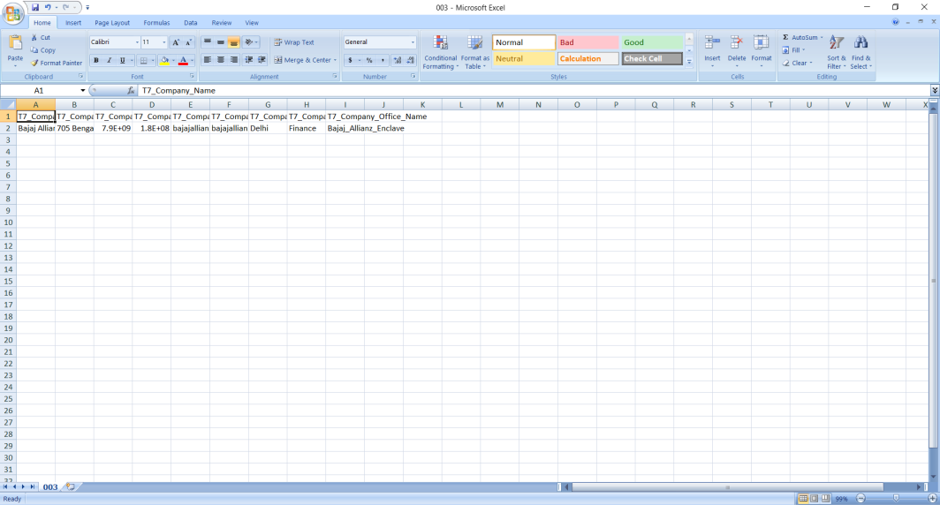

1. Select Customers who have more than one Vehicle, where the premium for one of the Vehicles is not paid and it is involved in accident

SELECT * FROM T7_CUSTOMER

WHERE T7_Cust_Id IN

(SELECT T7_Cust_Id FROM T7_VEHICLE GROUP BY T7_Cust_Id HAVING COUNT(*) > 1)

AND T7_Cust_Id IN

(SELECT T7_Cust_Id from T7_PREMIUM_PAYMENT WHERE ifnull(T7_Premium_Payment_Amount, 0) = 0)

AND T7_Cust_Id IN

(SELECT T7_Cust_Id from T7_INCIDENT_REPORT

WHERE T7_Incident_Type = 'accident');

**OUTPUT:**

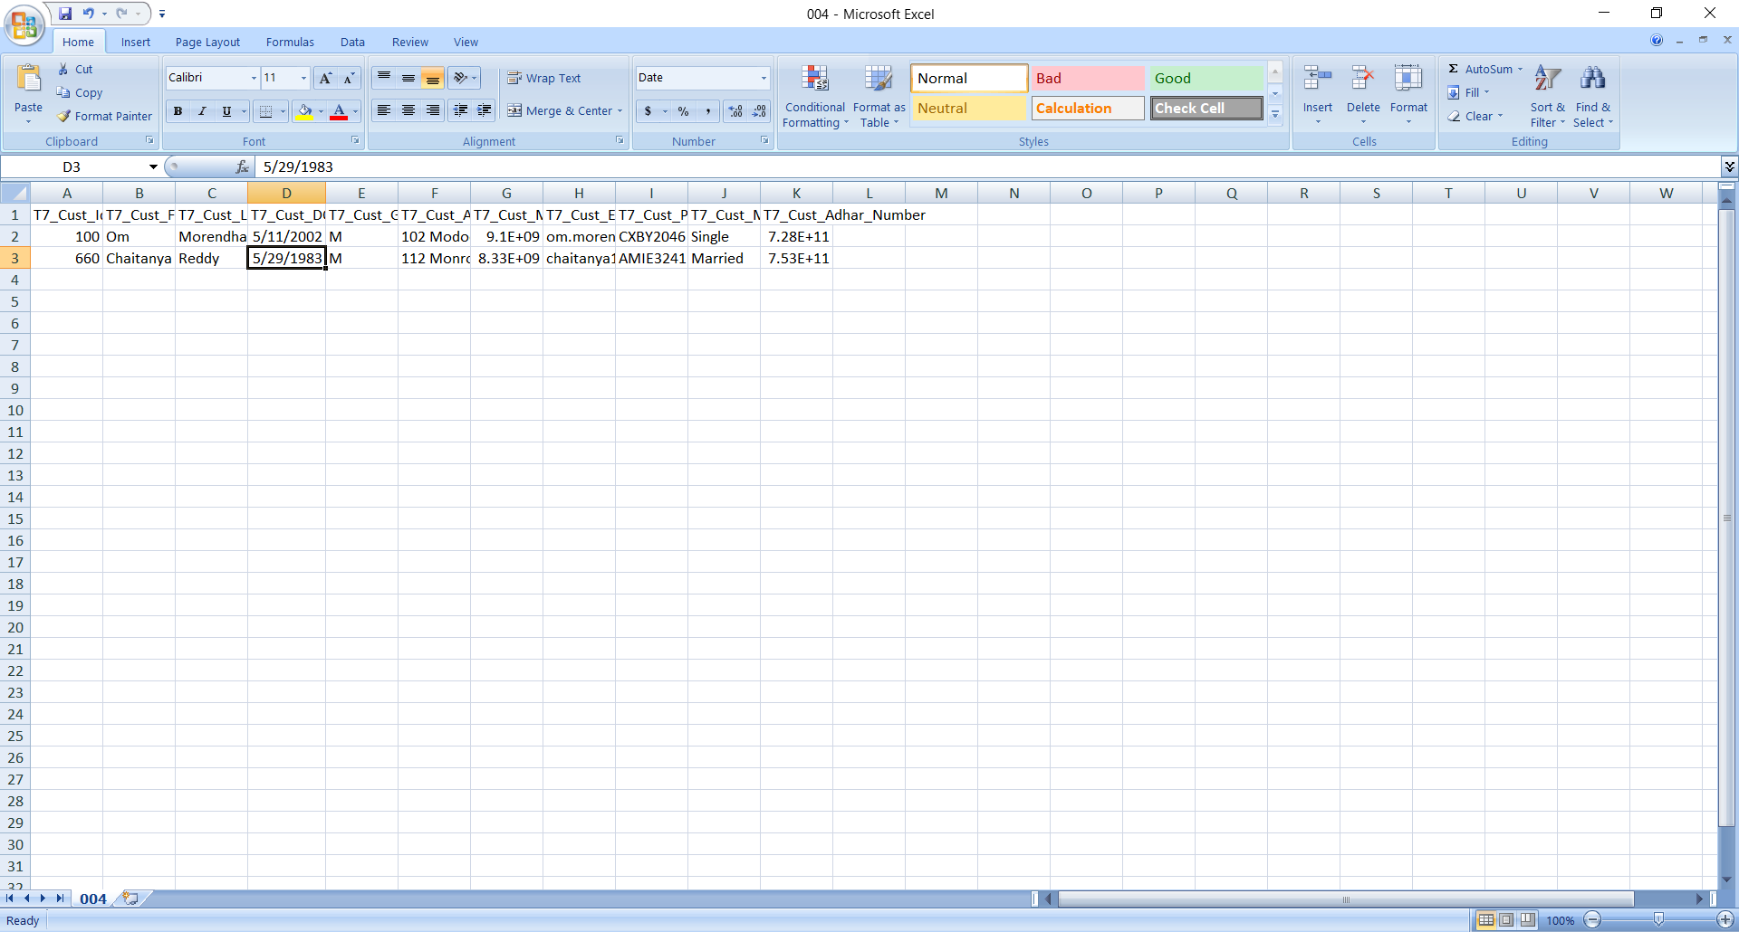

1. Select all vehicles which have premium more than its vehicle number.

SELECT T7_Vehicle_Id FROM T7_VEHICLE V

INNER JOIN T7_PREMIUM_PAYMENT P

ON V.T7_Policy_Number = P.T7_Policy_Number

WHERE P.T7_Premium_Payment_Amount > V.T7_Vehicle_Number;

**OUTPUT:**

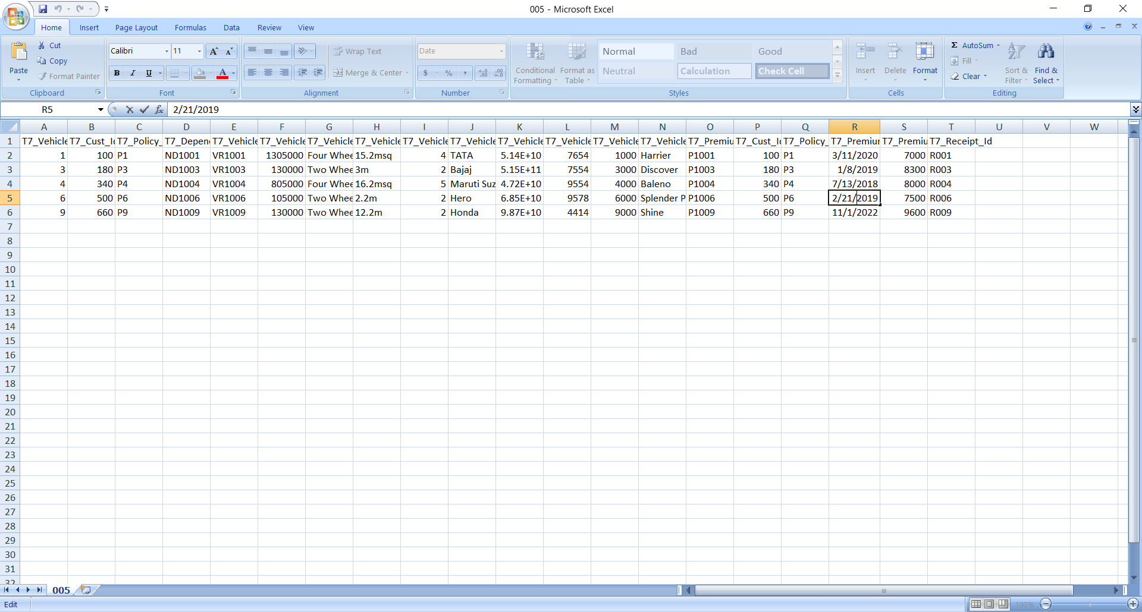

1. Retrieve Customer details whose Claim Amount is less than Coverage Amount and Claim Amount is greater than Sum of (CLAIM_SETTLEMENT_ID, VEHICLE_ID, CLAIM_ID, CUST_ID)

SELECT * FROM T7_CUSTOMER

WHERE T7_Cust_Id IN (SELECT T7_Cust_Id FROM (SELECT C.T7_Claim_Id, C.T7_Cust_Id , CS.T7_Coverage_Id FROM T7_CLAIM C

INNER JOIN T7_CLAIM_SETTLEMENT CS

ON C.T7_Claim_Id = CS.T7_Claim_Id

INNER JOIN T7_COVERAGE CV

ON CS.T7_Coverage_Id = CV.T7_Coverage_Id

WHERE (C.T7_Claim_Amount < CV.T7_Coverage_Amount)

AND (C.T7_Claim_Amount > CS.T7_Claim_Settlement_Id + CS.T7_Claim_Id + CS.T7_Cust_Id + CS.T7_Vehicle_Id)) AS T);

**OUTPUT:**

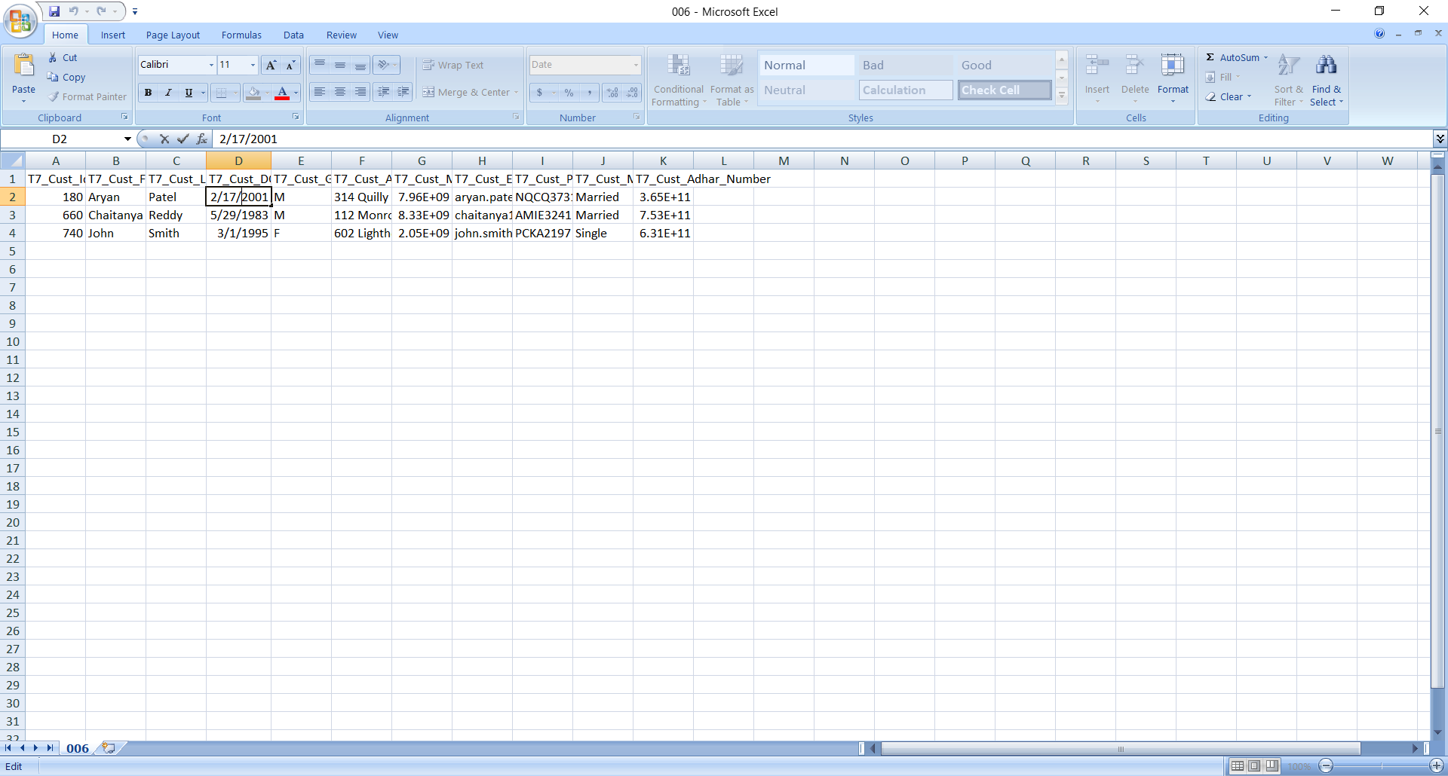

**CHALLENGES:**

1. **FOREIGN KEY CONSTRAINT:**

We have to change the sequence of table while creating their schema to ensure that is foreign key used has

been initialised as primary key.

1. **REWORKING THE DATABASE:**

We have to rework on database to satisfies the queries.

1. **Discrepancy in values between team members.**

**CONCLUSION:**

We have successfully created the database for vehicle insurance company and executed all the given queries.